Privacy Policy
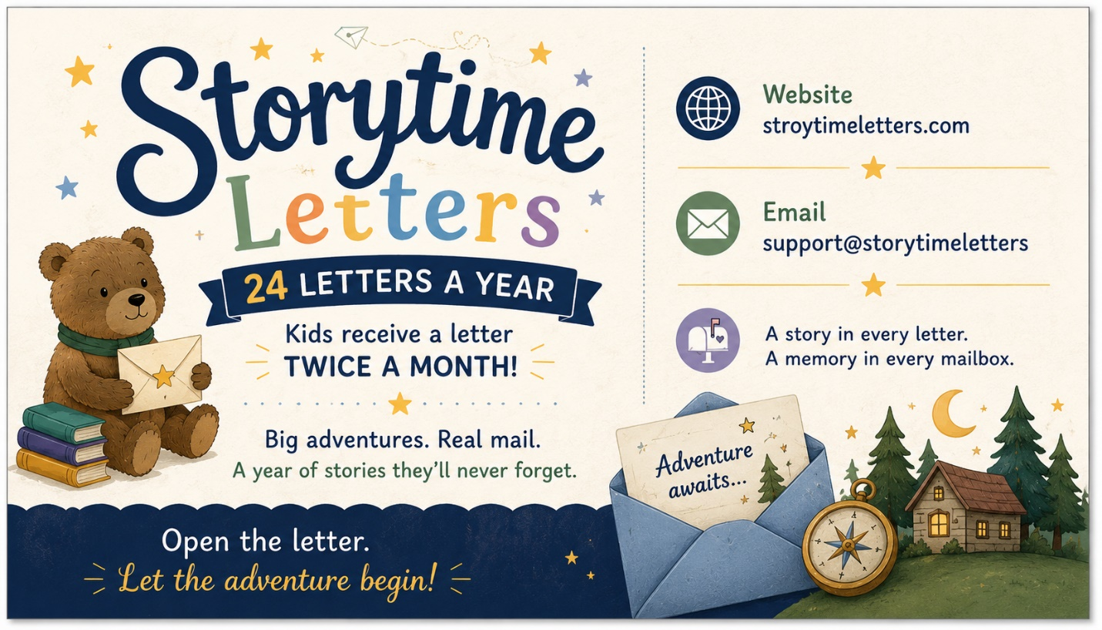

Last Updated: June 2026
Welcome to Storytime Letters. Your privacy is important to us. This Privacy Policy explains how Storytime Letters ("we," "our," or "us") collects, uses, and protects information when you visit our website or purchase our products and services.
Information We Collect
When you place an order, subscribe, or contact us, we may collect:
- Parent or guardian name
- Email address
- Mailing address
- Child's first name (for personalization purposes)
- Payment information (processed securely through our payment providers)
- Information you voluntarily provide through contact forms or customer support requests
How We Use Your Information
We use your information to:
- Process and fulfill orders
- Personalize Storytime Letters for your child
- Communicate about your subscription or purchase
- Respond to customer service inquiries
- Improve our website and services
- Send important updates related to your account or subscription
Children's Privacy
Storytime Letters is intended to be purchased by parents, guardians, or other adults. We do not knowingly collect personal information directly from children. Any information provided about a child is submitted by a parent or legal guardian for the purpose of personalizing the Storytime Letters experience.
Payment Information
Payments are processed through secure third-party payment providers. Storytime Letters does not store complete credit card information on our servers.
Sharing of Information
We do not sell, rent, or trade your personal information.
We may share information only with trusted service providers who help us operate our business, including payment processors, shipping providers, website hosting services, and email service providers.
Email Communications
We may send emails regarding your order, subscription, account information, or customer service requests. You may unsubscribe from promotional emails at any time.
Data Security
We take reasonable measures to protect your personal information from unauthorized access, disclosure, or misuse. However, no method of internet transmission or electronic storage is completely secure.
Cookies and Analytics
Our website may use cookies and similar technologies to improve user experience, analyze website traffic, and understand how visitors use our website.
You may disable cookies through your browser settings if desired.
Third-Party Links
Our website may contain links to third-party websites. We are not responsible for the privacy practices or content of those websites.
Your Rights
You may request to:
- Access your personal information
- Correct inaccurate information
- Delete your information
- Opt out of marketing communications
To make a request, please contact us using the information below.
Changes to This Policy
We may update this Privacy Policy from time to time. Changes will be posted on this page with an updated effective date.
Contact Us
If you have any questions regarding this Privacy Policy, please contact us at:
Storytime Letters
Email: support@storytimeletters.com
Website: storytimeletters.com

